CDS Push Notification Destinations
Determining where ‘push’ notifications are sent to

Abstract
Members of the external development community are intending to use ‘push’ notifications within CDS. There have been various questions raised about how the destination for ‘push’ notifications is determined – especially if a trade organisation uses multiple applications to interact with CDS. This document describes the behaviour of that mechanism.

Origin/Author: JB

Date Issued: 31 January 2020

Status: Baselined

Prepared by: HMRC (CDIO (CS&TD) – CDS)

Contents
1. ‘Push’ versus ‘Pull’ notification mechanisms 3
1.1 Pull notifications 3
1.2 Push notifications 3
1.3 Separation of notification mechanisms 3
2. Availability of notification mechanisms 3
3. API subscription model 3
3.1 Application subscriptions 3
3.2 Defining use of notifications 3
3.3 Scope of subscription 4
3.4 Subscription examples 4
4. Destination for push notifications 5
5. Sample sequence diagrams 6
5.1 Supplementary declaration submission 6
5.2 Submitting a pre-lodged inventory linked declaration 7

CDS notifications
CDS supports two types of delivery mechanisms for notifications, as described below.

Delivery mechanisms
CDS provides both ‘push’ and ‘pull’ delivery mechanisms to deliver notifications. These mechanisms are described in more detail in later sections but, in summary, ‘pull’ allows trade systems to request notifications from CDS, whilst ‘push’ allows CDS to send notifications to trade systems.

The fundamental difference between the two mechanisms is whether CDS or the trade system initiates delivery of the notification.

Availability of notification mechanisms
Both the pull and the push notification mechanisms are available for all CDS notifications originating from the current set of APIs.

Any notification could theoretically be delivered by either mechanism. In practise, the notification mechanism that will be used depends on what has been pre-selected for that API (see section 1.3).

Selection of notification mechanism
Each application that will consume CDS services determines which notification mechanism it will require, for each API it will use. i.e. A single application may use different notification mechanisms for different APIs; similarly a single API may use different notification mechanisms for different applications.

The details of how this is configured (via application subscriptions) is fully described below.

Separation of notification mechanisms
Push and pull notification deliveries use completely separate delivery mechanisms. Furthermore, messages only exist in one of those two delivery mechanisms. i.e. A notification will either be ‘pushed’ or ‘pulled’, but never both.

The consequence of this separation is that messages that will be/have been delivered via one mechanism cannot be retrieved via the other mechanism.

‘Push’ versus ‘Pull’ notification mechanisms

Pull notifications
The pull notification mechanism holds available notifications for subsequent retrieval by the consuming system. i.e. The trade system ‘pulls’ notifications when it is ready to do so. API endpoints allow identification of the stored notifications and the retrieval of selected notifications.

Pull retrieval also enables previously read notifications to be re-read if necessary.

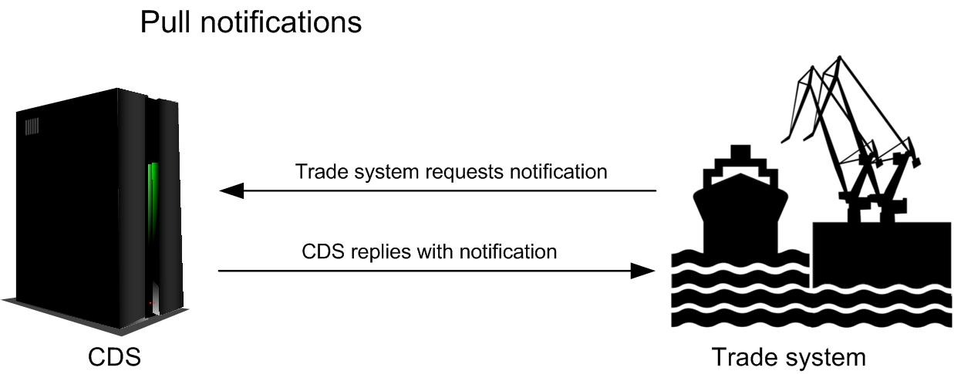

Push notifications
The push notification mechanism sends notifications out to the trade system as those notifications become available. i.e. CDS ‘pushes’ notifications as they are generated, and the trade system needs to be constantly ready to receive them.

CDS automatically retries failed deliveries. There are no API endpoints that would enable a re-delivery to be requested since:
- Successfully completed deliveries should, by definition, not need to be re-delivered.
- Pending deliveries are only known to CDS, since that is how the push model works.

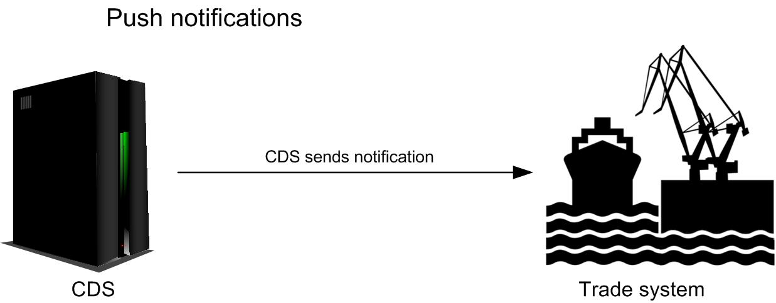

API subscription model
The API subscription model defines the characteristics of how applications interact with APIs.

Application subscriptions
Applications produced by external developers must subscribe to all of the CDS APIs that they intend to use. A subscription to an API will permit the subscribing application to access the endpoints within that API. An application may subscribe to a single API or to multiple APIs.

Each subscription uniquely links a single external application (typically a trade system) to a single CDS API, and records the information associated with that unique logical link.

Defining use of notifications
Part of an application’s subscription to an API, defines how notifications from the API will be delivered to that particular application. As noted in 1.2, all of the CDS APIs offer push and pull notifications. The details of each application’s subscription determines which mechanism (push or pull) is used for each application.

If the application’s subscription specifies a push notification callback URL, that will indicate that the API should use push notifications for that application – and should send those notifications to the supplied URL.

If the application’s subscription omits a callback URL, that will indicate to the API that pull notifications should be used with that application.

Scope of subscription
Because an API subscription uniquely links a single external application to a single CDS API, the scope of that subscription’s data is also limited to that unique association.

As described in 3.2, the type of notification mechanism is defined by the subscription. This leads to two key principles about the scope of notification mechanisms:

- The subscription to an API defines the notification mechanism, and hence all endpoints within a single API must share the same notification mechanism for a given subscription.
- An API requires a separate subscription for each application wishing to use that API, and hence a single API may use different notification mechanisms for different applications.

Subscription examples
The following diagrams illustrates key points described in the preceding text.

Use of single/multiple APIs
An application may subscribe to multiple APIs:

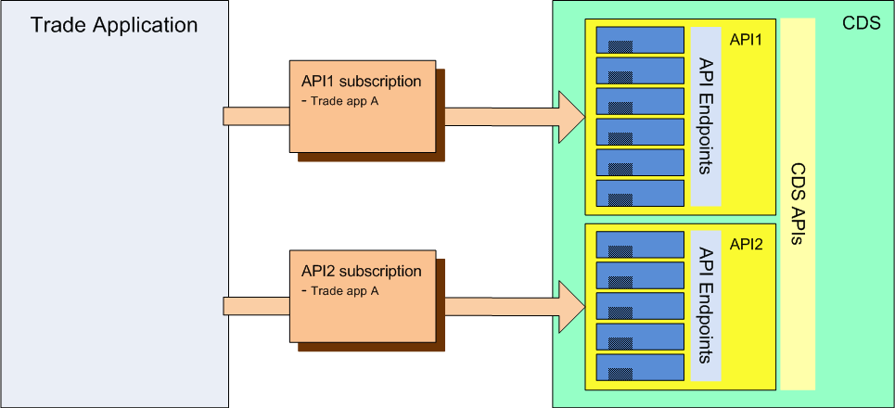

Alternatively an application may only subscribe to a single API:

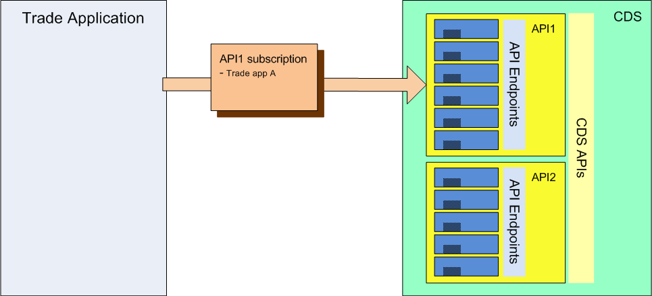

Mixed application notification mechanisms
An application may use push notifications for one subscription but use pull notifications for another subscription:

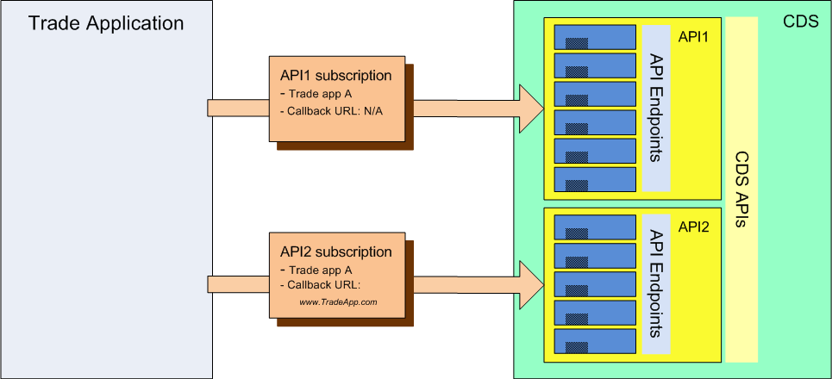

In the example above, the trade application uses pull notifications for API1 since no call back is defined. For API2, the same application will use push notifications to the defined callback URL: www.TradeApp.com.

Mixed API notification mechanisms
An single API may use different notification models for different application subscriptions .

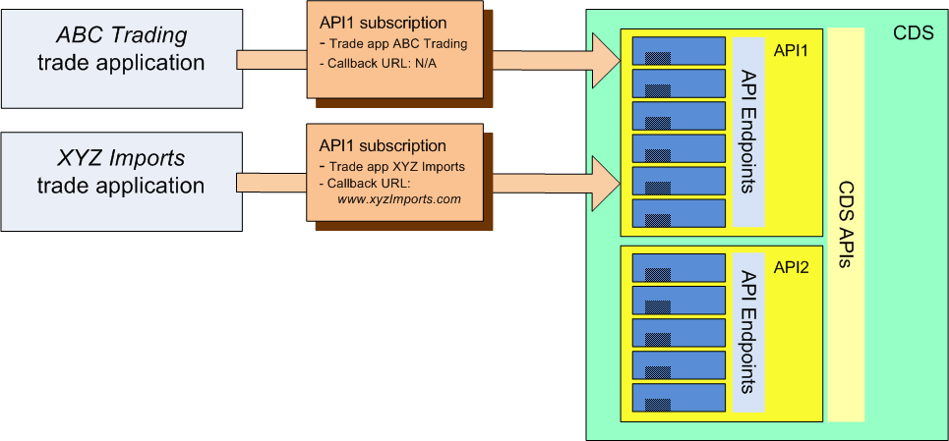

In the example above, two separate applications (from the two organisations ABC Trading and XYZ Imports have subscribed to the same CDS API. The ABC Trading application has not defined a callback URL and will therefore use pull notifications. The XYZ Imports application is using push notifications, sent to the supplied callback URL.

Mixed callback URLs
Because each callback URL is defined as part of a subscription, an application may define different callback URLs for different push notifications.

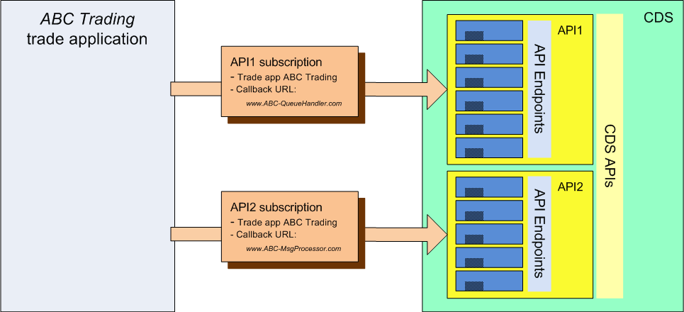

In the example above, although a single application has subscribed to both API1 and API2, the push notifications from each API will be sent to a different URL because different URLs are specified in the two subscriptions.

Although this approach is technically valid, whether it provides any practical value is an individual decision for each trader, since it depends on how that trader’s software system has been architected.

Determining the destination for notifications

Pull notifications
The question of notification destinations only applies to push notifications. Because pull notifications are initiated by the consuming system, those notifications are provided in response to an API call – and hence go back to the system initiating the call.

Push notifications
Although push notifications are initiated asynchronously by CDS, they will be associated to an existing transaction - to which the notification relates. And pre-existing internal CDS logic allows that original transaction to be associated with the external trade application from which it originated.
Since CDS already knows the API used for the original transaction then, once the originating application is identified, the API subscription for that application can be located. (Since, from 3.1, we know that every application wanting to use an API must first create a subscription before it can use an API.) Given the subscription, CDS is then able to extract the URL that was registered as part of the subscription – and hence determine the destination for the push notification.
So, to summarise, all push notifications associated with a particular transaction will be returned to the address registered by the application that invoked that transaction.

Sample sequence diagrams

Supplementary declaration submission
The following sequence diagram shows the process flow for an agent submitting a supplementary declaration via a CSP.
The initial API call is step 1b where the CSP’s application calls the CDS API. At this point the CDS authentication mechanism is able to identify the application making the API call – and to associate the transaction with that application.
Later in the declaration processing, the submission undergoes risking and duty calculation and then produces a subsequent notification for the CSP in step 4a.
- Where step 4a is using a push notification, the CDS system will use the identity of the application from step 1b to determine the relevant subscription – and hence the destination URL for the push delivery.
- Where step 4a is using a pull notification, the CDS system will store the message locally and wait for the agent’s software to retrieve it.

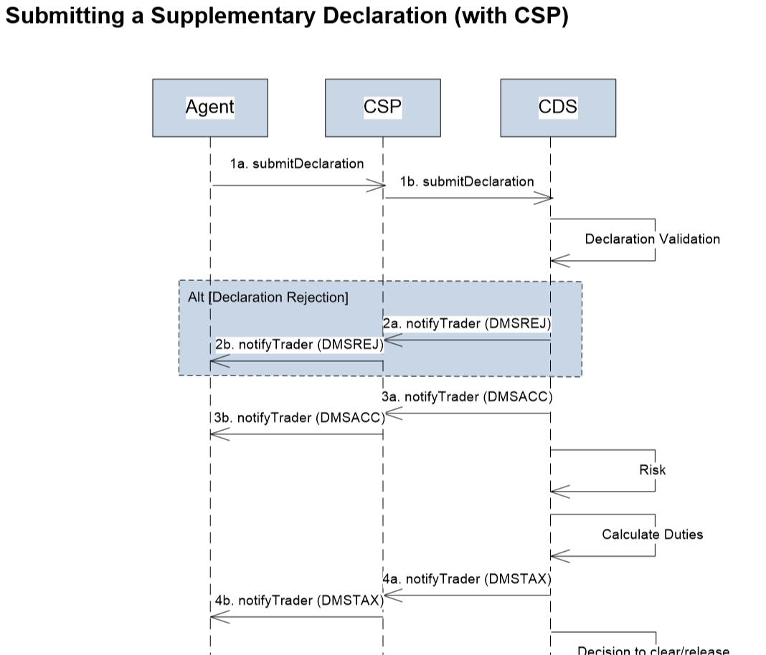

Submitting a pre-lodged inventory linked declaration
The following sequence diagram shows the process flow for an agent submitting a pre-lodged inventory linked declaration, via a CSP.
The initial API call is step 1b where the CSP’s application calls the CDS API. As with the previous example, this is the point at which the CDS authentication mechanism is able to identify the application making the API call – and to associate the transaction with that application.
Later in the declaration workflow (step 3, after validation of the declaration) CDS sends a Validate Movement Request for processing by the CSP’s inventory linking system.
- Where step 3 is using a push notification, the CDS system will use the identity of the application from step 1b to determine the relevant subscription – and hence the destination URL for the push delivery.
- Where step 3 is using a pull notification, the CDS system will store the message locally and wait for the agent’s or declarant’s software to retrieve it.

Note that in this inventory linked example the destination is still derived from the application subscription. i.e. There is no separate delivery mechanism or separate destination URL for inventory linking activities.
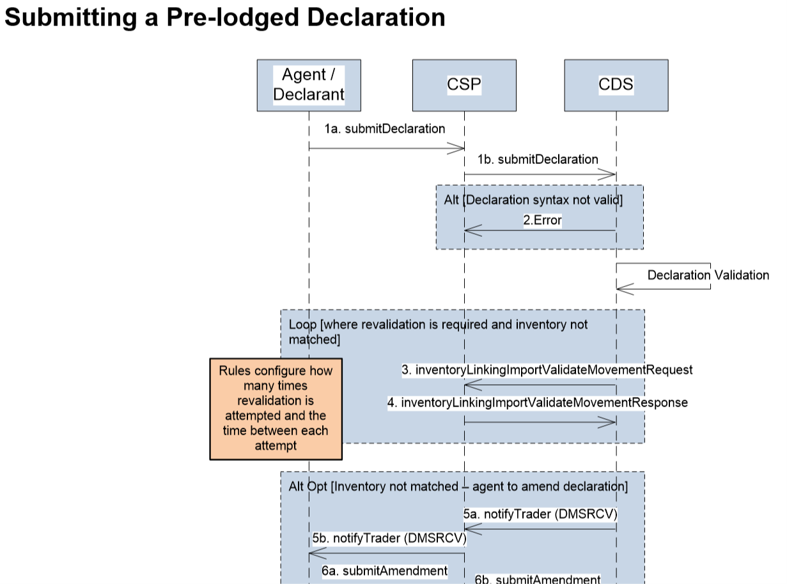

Document Control
Status:
Author | JB
Status | Baselined

Change Log:
Version | Date | Author | Comments
0.1 | 07-Nov-2019 | JB | Release for internal review
0.2 | 13-Nov-2019 | JB | Revised sample sequence diagrams
0.2a | 15-Jan-2020 | JB | Revised content to suit a broader audience
1.0 | 31-Jan-2020 | JB | Baselined version to be issued
Statement of Confidentiality
© HM Revenue & Customs 2019
All rights reserved.

